Sustainable Cooking Club
Lessons 1 to 6
Sustainable Cooking Club

Lesson 1

Main: Falafel burgers

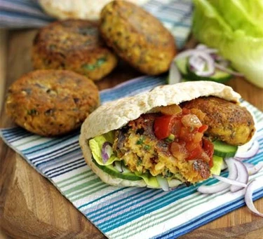
Serves 4
Prep: 10 mins
Cook :6 mins

Ingredients
- 400g can chickpeas, rinsed and drained
- 1 small red onion, roughly chopped
- 1 garlic clove, chopped
- handful of flat-leaf parsley or curly parsley
- 1 tsp ground cumin
- 1 tsp ground coriander
- ½ tsp harissa paste or chilli powder
- 2 tbsp plain flour
- 2 tbsp sunflower oil
- toasted pitta bread, to serve
- 200g tub tomato salsa, to serve
- green salad, to serve

Method
STEP 1
Drain the chickpeas and pat dry with kitchen paper. Tip into a food processor along with the onion, garlic, parsley, cumin, coriander, harissa paste, flour and a little salt. Blend until fairly smooth, then shape into four patties with your hands.
STEP 2
Heat the sunflower oil in a non-stick frying pan, and fry the burgers for 3 mins on each side until lightly golden. Serve with the toasted pitta bread, tomato salsa and green salad.

Here’s a cooking tip for you…

VEGAN ≠ ENVIRONMENTALLY FRIENDLY
Be aware that choosing vegan packaged foods isn’t always the most environmentally friendly option. For example, falafel and salads are usually wrapped up in loads of plastic – have a go at making your own instead!

Desert: Vegan Brownies
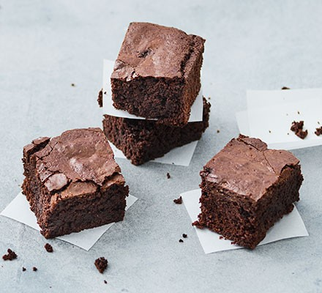
Makes 12
Prep: 15 mins
Cook: 40 mins

Ingredients
- 2 tbsp ground flaxseed
- 200g dark chocolate, roughly chopped
- ½ tsp coffee granules
- 80g vegan margarine, plus extra for greasing
- 125g self-raising flour
- 70g ground almonds
- 50g cocoa powder
- ¼ tsp baking powder
- 250g golden caster sugar
- 1½ tsp vanilla extract
Method
STEP 1
Heat the oven to 170C/150C fan/gas 3½. Grease and line a 20cm square tin with baking parchment. Combine the flaxseed with 6 tbsp water and set aside for at least 5 mins.
STEP 2
In a saucepan, melt 120g chocolate, the coffee and margarine with 60ml water on a low heat. Allow to cool slightly.
STEP 3
Put the flour, almonds, cocoa, baking powder and ¼ tsp salt in a bowl and stir to remove any lumps. Using a hand whisk, mix the sugar into the melted chocolate mixture, and beat well until smooth and glossy, ensuring all the sugar is well dissolved. Stir in the flaxseed mixture, vanilla extract and remaining chocolate, then the flour mixture. Spoon into the prepared tin.
STEP 4
Bake for 35-45 mins until a skewer inserted in the middle comes out clean with moist crumbs. Allow to cool in the tin completely, then cut into squares. Store in an airtight container and eat within three days.

Lesson 2
Main: Kidney bean Curry
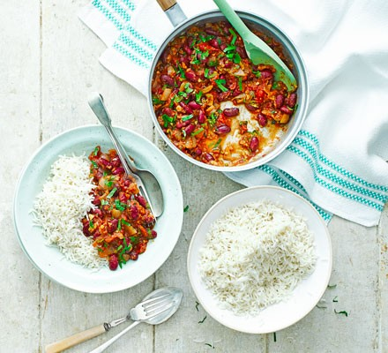
Serves 2
Prep: 5 mins
Cook: 30 mins

Ingredients
- 1 tbsp vegetable oil
- 1 onion, finely chopped
- 2 garlic cloves, finely chopped
- thumb-sized piece of ginger, peeled and finely chopped
- 1 small pack coriander, stalks finely chopped, leaves roughly shredded
- 1 tsp ground cumin
- 1 tsp ground paprika
- 2 tsp garam masala
- 400g can chopped tomatoes
- 400g can kidney beans, in water
- cooked basmati rice, to serve

Method
STEP 1
Heat the oil in a large frying pan over a low-medium heat. Add the onion and a pinch of salt and cook slowly, stirring occasionally, until softened and just starting to colour. Add the garlic, ginger and coriander stalks and cook for a further 2 mins, until fragrant.
STEP 2
Add the spices to the pan and cook for another 1 min, by which point everything should smell aromatic. Tip in the chopped tomatoes and kidney beans in their water, then bring to the boil.
STEP 3
Turn down the heat and simmer for 15 mins until the curry is nice and thick. Season to taste, then serve with the basmati rice and the coriander leaves.

Lesson 3
Main: Vegan pizza Margherita

Makes 2 or 4 large pizzas
Prep: 15 mins
Cook: 15 mins

Ingredients

For the pizza dough
- 500g strong white bread flour, plus extra for dusting
- 1 tsp dried yeast
- 1 tsp caster sugar
- 1 ½ tbsp olive oil, plus extra

For the tomato sauce
- 100ml passata
- 1 tbsp fresh basil, chopped (or 1/2 tsp dried oregano)
- 1 garlic clove, crushed

For the topping
- 200g vegan mozzarella-style cheese, grated
- 2 tomatoes, thinly sliced
- Fresh basil or oregano leaves, chilli oil and vegan parmesan to serve (optional)

Method
STEP 1
Put the flour, yeast and sugar in a large bowl. Measure 150ml of cold water and 150ml boiling water into a jug and mix them together – this will mean your water is a good temperature for the yeast. Add the oil and 1 tsp salt to the warm water then pour it over the flour. Stir well with a spoon then start to knead the mixture together in the bowl until it forms a soft and slightly sticky dough. If it’s too dry add a splash of cold water.
STEP 2
Dust a little flour on the work surface and knead the dough for 10 mins. Put it back in the mixing bowl and cover with cling film greased with a few drops of olive oil. Leave to rise in a warm place for 1 hr or until doubled in size.
STEP 3
Heat oven to 220C/200C/gas 9 and put a baking sheet or pizza stone on the top shelf to heat up. Once the dough has risen, knock it back by punching it a couple of times with your fist then kneading it again on a floured surface. It should be springy and a lot less sticky. Set aside while you prepare the sauce.
STEP 4
Put all the ingredients for the tomato sauce together in a bowl, season with salt, pepper and a pinch of sugar if you like and mix well. Set aside until needed.

STEP 5
Divide the dough into 2 or 4 pieces (depending on whether you want to make large or small pizzas), shape into balls and flatten each piece out as thin as you can get it with a rolling pin or using your hands. Make sure the dough is well dusted with flour to stop it sticking. Dust another baking sheet with flour then put a pizza base on top – spread 4-5 tbsp of the tomato sauce on top and add some sliced tomatoes and grated vegan cheese. Drizzle with a little olive oil and bake in the oven on top of your preheated baking tray for 10-12 mins or until the base is puffed up and the vegan cheese has melted and is bubbling and golden in patches.
STEP 6
Repeat with the rest of the dough and topping. Serve the pizzas with fresh basil leaves or chilli oil if you like and sprinkle over vegan parmesan just after baking.

Here’s a cooking tip for you…

CUT DOWN ON MEAT AND DAIRY
Start by trying to eat vegetarian one night a week (hello Meat Free Monday) and include some simple swaps into your diet. Quorn is an excellent substitute and there is a growing market of veggie-friendly foods becoming available in all supermarkets.

Lesson 4
Main: Sticky Noodles with homemade hoisin
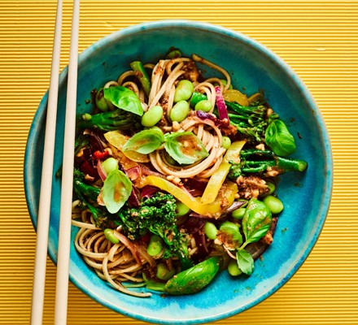
Serves 2

Prep: 10 mins
Cook: 20 mins – 25 mins

Ingredients

For the hoisin
- 2 tbsp raisins
- 1 garlic clove
- 1 tbsp apple cider vinegar
- 2 tsp tomato purée
- 1 tsp tamari, plus extra to serve (optional)
- 1 tsp Chinese five spice
- 2 tbsp crunchy peanut butter (without palm oil or sugar)

For the stir-fry
- 2 nests wholemeal noodles (75g)
- 1 tsp rapeseed oil
- 1 tbsp chopped ginger
- 1 yellow pepper, deseeded and thinly sliced
- 2 red onions (173g), thinly sliced
- 100g long stem broccoli, halved
- 100g frozen soya beans, thawed
- 1 red chilli, seeded and chopped
- handful basil leaves

Method
STEP 1
Put the raisins in a measuring jug or small, high-sided bowl, pour over 100ml boiling water then stir in the garlic, vinegar, tomato purée, tamari and five spice. Blitz with a hand blender until smooth, then stir in the peanut butter until well mixed.
STEP 2
Pour boiling water over the noodles and soak for 5 mins. Heat the oil in a non-stick wok, add the ginger with the vegetables and chilli and stir-fry for 5 mins or more until the veg have softened, but still have some bite.
STEP 3
Drain the noodles and add to the pan with the hoisin. Toss well adding a little extra water if necessary to moisten, then toss through the basil leaves.

Here’s a cooking tip for you…

USE ALL YOU CAN
Use all parts of the food – the stalks of mushrooms, leaves of celery, beet greens, apple peel, potato skin and broccoli stalks. As long as it’s edible there can always be a second opportunity to use it!

